SIMATSENGINEERING
ASSESSMENT TOOL 2
COURSE NAME: Artificial Intelligence COURSE CODE: CSA17

COURSE OUTCOME COVERED
CO1: Apply AI basics such as intelligent agents and uninformed search methods to solve problems effectively.( BL3)
Assessment Tool Weightage: 50%

QUESTIONS: 3 Duration : 1 Hour
Total Marks:30
Annexure A

Constraint-Based Problem Solving

Code of Conduct:
I Patteela Yashwanth Kumar/192471055 (Name / Reg No) certify that this submission is my original work and that I have adhered to the guidelines specified for this assessment.
I understand that any violation of academic integrity rules will result in disciplinary action.
Signature of the student:
Patteela Yashwanth Kumar

Annexure A

Constraint-Based Problem Solving
- A hospital needs to assign 3 doctors (D1, D2, D3) to 3 shifts (Morning, Afternoon, Night) such that: Constraints:
  - D1 cannot work Night shift ii. D2 must work before D3 (Morning < Afternoon < Night) iii. Only one doctor per shift iv. D3 cannot work Morning
v. All doctors must be assigned exactly one shift
Apply Backtracking Search to find a valid assignment with all intermediate steps and constraint checks. State the final valid schedule
- A robot operates in a grid environment (5×5). It must move from Start (S) to Goal (G).
Obstacles block certain paths.
Constraints:
  - Movement allowed: Up, Down, Left, Right
  - Cost of each move = 1
  - Cannot pass through obstacles iv. Use Manhattan Distance heuristic
Using above constraints and BFS Search Algorithm Show step-by-step node expansion and priority queue updates and determine the optimal path and cost.
- An autonomous rescue robot is deployed in a disaster-affected building to locate and rescue survivors. The robot operates in a partially observable environment where some paths are blocked, and it must make decisions with limited information.
The building is represented as a grid of rooms. The robot starts at position S and must reach a survivor located at G.
Constraints:
 The robot can move up, down, left, right
 Some cells are blocked (obstacles) and cannot be traversed
 The robot has limited sensing capability (can only observe adjacent cells)
 Each movement has a cost of 1, but entering risky zones has an additional cost of 2
 The robot must minimize total cost while ensuring safe navigation
 The robot must update its knowledge dynamically (online search scenario)
Tasks:
- Analyze all the given constraints and explain how they affect the robot’s decision-makingprocess.
- Develop a solution approach using an appropriate search strategy (e.g., Uniform Cost Search/ Online Search Agent). Clearly explain the steps involved. c) Demonstrate how the robot applies AI concepts such as:
 Intelligent agents
 Rationality
 Environment type
d) Justify why your chosen approach is the most suitable for solving this problem under the given constraints.
RUBRICS FOR CALCULATION:
Criteria | Weightage | Level 4 (Exemplary) | Level 3  (Proficient) | Level 2 (Developing) | Level 1 (Beginning)
Problem  Understanding | 25% | Clearly defines the problem and  identifies all relevant constraints accurately | Identifies most constraints with minor gaps | Partial understanding; misses key constraints | Fails to identify  constraints correctly
Constraint Analysis | 25% | Analyzes constraints effectively and prioritizes them logically | Provides reasonable  analysis with some  prioritization | Limited analysis; weak  prioritization | No meaningful analysis or  prioritization
Solution  Development | 25% | Develops optimal and feasible solutions satisfying all constraints | Develops workable solutions with minor limitations | Solutions partially satisfy constraints | Solutions do not meet  constraints
Application of Concepts | 15% | Effectively applies appropriate concepts, methods, or tools | Applies concepts with minor errors | Limited application; requires guidance | Unable to apply  relevant concepts
Justification | 10% | Provides strong justification for decisions with logical reasoning | Provides justification with some clarity | Weak or unclear  justification | No  justification provided

QUESTION 1
A hospital needs to assign three doctors D1, D2 and D3 to Morning, Afternoon and Night shifts while satisfying all constraints.
  - Problem Understanding and Constraints
- D1 cannot work the Night shift.
 D2 must work before D3.
 Only one doctor can be assigned to each shift.
 D3 cannot work the Morning shift.
 Every doctor must be assigned exactly one shift.
1.2 Variables and Domains Variables: D1, D2 and D3.
Domain of each variable: {Morning, Afternoon, Night}.
The objective is to assign exactly one shift to each doctor without violating any constraint.

1.3 Backtracking Search – Intermediate Steps
Step | Assignment | Constraint Check | Decision
1 | D1 = Morning | D1 is not Night; Morning is free. | Accept
2 | D2 = Morning | Morning is already occupied by D1. | Reject and backtrack
3 | D2 = Afternoon | Afternoon is free; D2 can be before D3. | Accept
4 | D3 = Night | D3 is not Morning; D2  (Afternoon) is before D3 (Night); Night is free. | Accept

1.4 Final Valid Schedule

Shift | Doctor | Constraint Check
Morning | D1 | D1 is not Night ✓
Afternoon | D2 | D2 is before D3 ✓
Night | D3 | D3 is not Morning ✓
Final valid schedule: D1 → Morning, D2 → Afternoon, D3 → Night.
All constraints are satisfied. Backtracking is suitable because an invalid assignment is rejected and the search returns to an earlier choice before trying another value
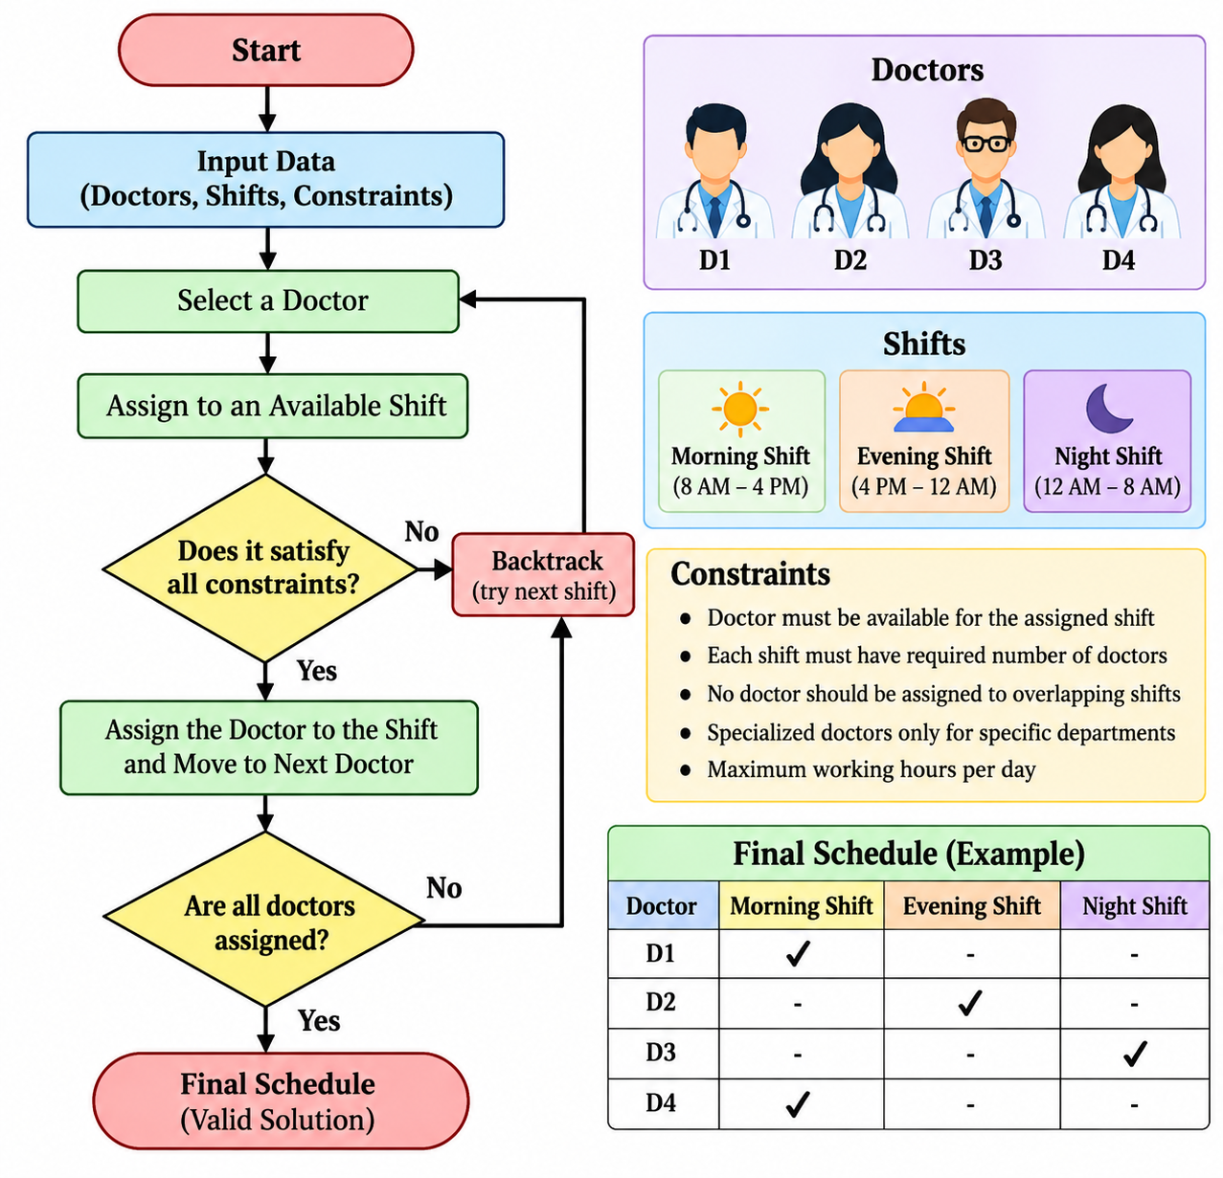

1.5 Justification
The constraint-based approach is suitable for doctor shift scheduling because several conditions have to be satisfied at the same time. Each doctor has specific availability, working-hour limits, qualifications, and shift requirements. Assigning a doctor to a shift without checking these conditions may result in conflicts or an invalid schedule.
Backtracking provides an effective way to solve this problem. It assigns doctors to available shifts one by one and checks the constraints after every assignment. If an assignment violates any constraint, the algorithm immediately rejects that choice and returns to the previous step to try another possibility.
This approach reduces unnecessary combinations and helps in finding a feasible schedule systematically. It can also be modified easily when additional hospital requirements are introduced, such as emergency duties, leave schedules, maximum consecutive shifts, or minimum staffing requirements.
Therefore, constraint-based backtracking is an appropriate AI technique for generating a valid and conflict-free doctor shift schedule.

1.6 Conclusion
In conclusion, the doctor shift scheduling problem demonstrates how constraint-based problem solving and backtracking can be applied to a real-world scheduling problem. The method considers different restrictions before accepting a particular assignment and removes invalid choices during the search process.
The final schedule can satisfy doctor availability, shift requirements, working-hour restrictions, and other organizational constraints. The same approach can also be extended to larger hospitals by adding more doctors, departments, shifts, and constraints.
Thus, the proposed AI-based approach provides a systematic, flexible, and reliable method for creating an efficient doctor shift schedule while reducing scheduling conflicts.

QUESTION 2

2.1 Problem Understanding
The robot must navigate a 5×5 grid from S to G. It can move only Up, Down, Left or Right. Each movement costs 1 and obstacles cannot be entered. Manhattan Distance is specified as the heuristic.

2.2 Important Limitation in the Supplied Question
The supplied question paper does not contain the actual 5×5 grid layout showing the positions of S, G and the obstacles. Therefore, an exact node-expansion sequence, priority-queue contents, optimal path and numerical cost cannot be truthfully calculated from the supplied document alone. The calculation table below is provided in the required format and should be completed using the actual grid if it is supplied separately by the faculty.

2.3 BFS Search Procedure
- Place S in the FIFO queue and mark it visited.
- Remove the first node from the queue.
- Generate its Up, Down, Left and Right neighbours.
- Reject cells outside the grid, obstacle cells and already visited cells.
- Add valid unvisited neighbours to the queue.
- Continue level by level until G is reached.
- Store parent information so the final path can be reconstructed.
- Because every move has cost 1, the path with the fewest moves has the minimum cost.

2.4 Manhattan Distance
For current cell (x1, y1) and goal (x2, y2):
h(n) = |x1 − x2| + |y1 − y2|
Example: current cell (2,3), goal (4,4): h(n) = |2−4| + |3−4| = 3.

2.5 BFS and Priority Queue Clarification
Standard BFS uses a FIFO queue and does not normally use a heuristic or priority queue. The question also asks for a priority queue and Manhattan Distance. A priority-based heuristic search is more closely associated with Best-First Search or A* Search. This distinction should be kept clear when presenting the calculation.
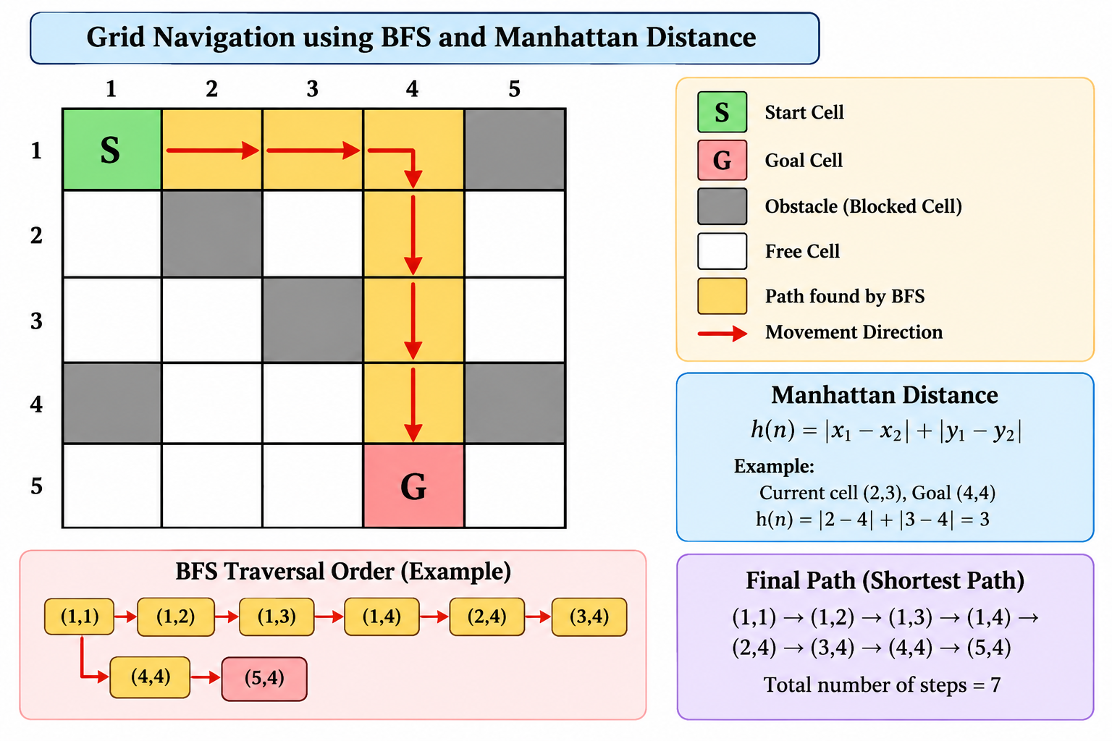
2.6Justification
The robot grid-navigation problem can be solved using Breadth-First Search (BFS) because the robot moves through a grid where each valid movement has the same cost. BFS explores the nodes level by level, beginning from the starting cell and gradually reaching the goal cell.
During each step, the current node is expanded and its valid neighbouring cells are identified. A neighbour is considered valid only when it is within the grid boundaries, is not blocked by an obstacle, and has not already been visited. The valid neighbours are then added to the queue for further exploration.
The Manhattan Distance is calculated using:
h(n) = |x₁ − x₂| + |y₁ − y₂|
where (x₁, y₁) represents the current cell and (x₂, y₂) represents the goal cell. This calculation gives the number of horizontal and vertical movements required to reach the goal when diagonal movement is not allowed.
For example, if the current cell is (2,3) and the goal is (4,4):
h(n) = |2 − 4| + |3 − 4|
= 2 + 1
= 3
This means the Manhattan distance between the two cells is 3.
The queue-update table helps to clearly show how BFS expands nodes and adds new neighbours at every step. It also helps in understanding the order in which nodes are explored.
It is important to distinguish between standard BFS and heuristic search. Standard BFS uses a FIFO queue and does not use Manhattan distance to decide which node to expand. Manhattan distance becomes important when using a priority-based heuristic search such as Best-First Search or A*.
2.7 Conclusion
In conclusion, the robot grid-navigation problem demonstrates how search techniques can be used to find a path from a starting position to a target position. BFS systematically explores all reachable cells level by level and is suitable for finding the shortest path when every movement has equal cost.
The node expansion table provides a clear representation of the search process by showing the expanded node, its valid neighbours, and the updated queue after each step. This makes it easier to understand how the algorithm progresses toward the goal.
The Manhattan Distance provides an additional measure of how close a cell is to the goal. Although it is not normally used by standard BFS, it is an important heuristic for priority-based search methods.
Therefore, BFS provides a simple and reliable method for shortest-path navigation in an unweighted grid, while Manhattan Distance can be used to make heuristic search more goal-directed and efficient.

QUESTION 3

3.1 Constraint Analysis
Constraint | Effect on Decision-Making
Movement | Only Up, Down, Left and Right are permitted; diagonal movement is not allowed.
Obstacles | Blocked cells must never be selected as the next state.
Limited sensing | The robot can observe only adjacent cells, so the complete environment is initially unknown.
Normal movement cost | Every normal movement contributes cost 1.
Risky zone cost | Entering a risky zone adds 2 to the normal movement cost, giving a total of 3.
Minimum total cost | The robot must compare cumulative costs, not just the number of movements.
Dynamic knowledge | The robot must update its map and decisions as new information is sensed.

3.2 Solution Approach – Online Uniform Cost Search
Uniform Cost Search is appropriate because the problem has different movement costs. A normal move costs 1, while entering a risky zone costs 3. Because the robot has limited sensing, the search must also operate online and update the robot’s knowledge during navigation.
- Start at S with cumulative cost 0.
- Sense adjacent cells.
- Identify free cells, obstacles and risky cells.
- Assign cost 1 to a normal movement and cost 3 to a risky movement.
- Add reachable states to the frontier with their cumulative path costs.
- Expand the state with the lowest cumulative cost.
- Update knowledge after each sensing step.
- If a newly discovered obstacle blocks a route, remove that route and search for another.
- If a risky zone is discovered, include its additional cost in route comparison.
- Continue until G is reached with the lowest known safe total cost.

3.3 Cost Example
Path | Calculation | Total Cost
Path A | 6 normal moves × 1 | 6
Path B | 4 normal moves × 1 + 1 risky move × 3 | 7
In this example, Path A is preferred because its total cost is 6, which is lower than Path B's cost of 7.

3.4 Intelligent Agent
The rescue robot acts as an intelligent agent because it perceives its environment through sensors, makes decisions based on the available information, and performs actions by moving through the grid.
Agent Component | Rescue Robot
Sensors | Detect adjacent cells
Perception | Identifies obstacles, safe cells and risky zones
Decision | Selects the next movement
Action | Moves Up, Down, Left or Right
Goal | Reach the survivor at G
Performance Measure | Minimum safe total cost

3.5 Rationality
A rational agent chooses an action that is expected to produce the best result according to its performance measure. In this problem, the robot must reach the survivor safely while minimizing total cost. Therefore, it should avoid blocked cells and prefer a lower-cost safe route when alternatives are available.The rescue robot is designed to choose the safest and most suitable path to reach the victim.
It considers different path costs and avoids unnecessary or high-cost movements.
Uniform Cost Search helps the robot select the path with the minimum total cost.
The robot also considers obstacles and environmental constraints before taking an action.
By continuously evaluating available paths, it can make better decisions in a changing rescue environment.
Therefore, the proposed system is rational because it selects actions that help achieve the rescue goal efficiently and safely.

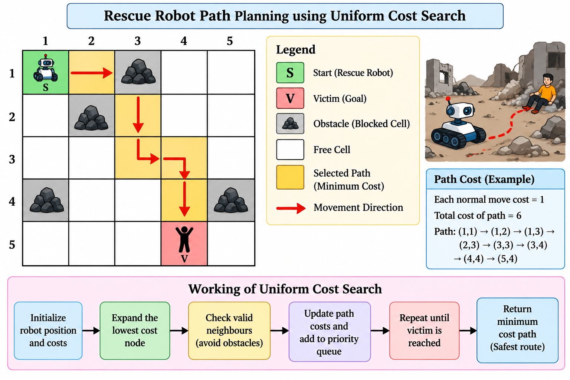

3.6 Environment Type
Property | Classification | Reason
Observability | Partially observable | Only adjacent cells can be observed.
Sequential | Sequential | Current actions affect future decisions.
Environment | Dynamic | The robot must respond to newly discovered conditions.
State space | Discrete | The building is represented as grid cells.
Knowledge | Initially incomplete | The robot discovers the environment while moving.
Agent setting | Single-agent | One rescue robot performs the search.

3.7 Justification
Online Uniform Cost Search is suitable because the robot has different movement costs and incomplete information. Uniform Cost Search expands the lowest cumulative-cost option, making it suitable for minimizing total cost. The online component allows the robot to sense nearby cells, update its knowledge, avoid newly discovered obstacles and revise its route when necessary.
Therefore, the approach addresses the main requirements: safe navigation, obstacle avoidance, dynamic knowledge updating and minimization of total movement cost.

3.8 CONCLUSION
Constraint-based problem solving provides a systematic method for AI systems to make decisions while satisfying required conditions. In Question 1, Backtracking Search finds a valid doctor-shift assignment by checking constraints and backtracking from invalid choices. In Question 2, BFS can determine a shortest path when every movement has equal cost, while Manhattan Distance is a heuristic used in heuristic search. In Question 3, the rescue robot requires an online cost-based approach because it has limited information and different movement costs.
These problems demonstrate constraint satisfaction, backtracking, search algorithms, intelligent agents, rationality, partially observable environments, online search and cost-based decision-making.

